Bilinguo

UI Prototype

Version 1.0

Revision History

| **Date** | **Version** | **Description** | **Author** |
| --- | --- | --- | --- |
| 25/05/2024 | 1.0 | Add UI for the main screen, key scenarios and provide the description below each screen. | Tấn Phát  Ngọc Châm |
|  |  |  |  |
|  |  |  |  |
|  |  |  |  |
|  |  |  |  |

Table of Contents

**1. Homepage 4**

**2. Sign in 5**

**3. Dictionary 6**

**4. Teacher role** 8

4.1. Teacher’s Homepage 8

4.2. Create mock test/quizzies 9

4.3. Dictionary 10

**5. Leaner role 11**

5.1. Sign up 11

5.2. Leaner’s homepage 12

5.3. Flashcards 13

5.3.1. Flashcards library 13

5.3.2. Create Flashcards 16

5.4. Mock test 19

**6. Admin role 20**

6.1. Admin’s homepage 20

6.2. View accounts 21

6.3. Report 22

6.4. Authorize account 23

# 1. Homepage

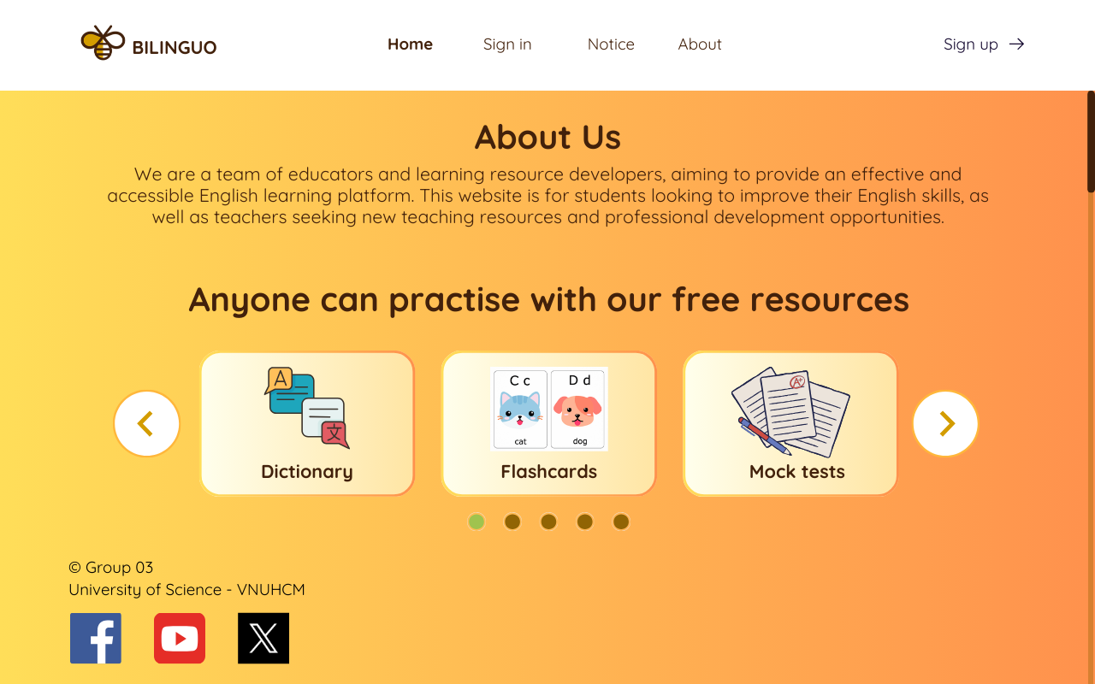

**- Purpose:** Introduce an overview of Bilinguo, including information about the development team, key features, and contact details.

**- User guide:** From the main screen, users can choose to **Sign in**, **Sign up** for a new account, view update notifications (**Notice**), and access detailed information about the software (**About**).

# 2. Sign in

# 

**- Purpose:** Users log in to save their data when using the platform and to differentiate themselves from other users.

**- User guide:**

+ Admins and teachers log in using special accounts provided before without needing to register themselves.

+ Learners log in with registered accounts; if they don't have an account, they can choose to **Sign up** to create a new one.

+ Users can click on the **Forgot password** section to retrieve their password if they forget it.

# 3. Dictionary

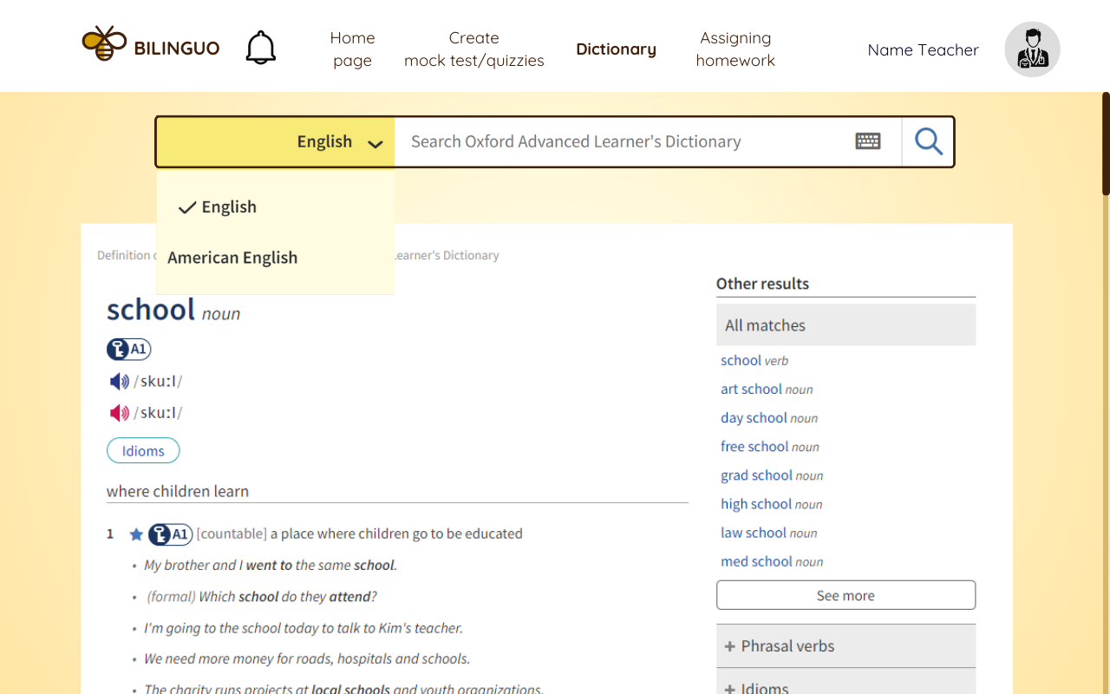

**- Purpose:** Look up vocabulary to see their meanings and related examples.

**- User guide:** Users can choose the language they want to use and input the vocabulary into the text input box to look up its meaning.

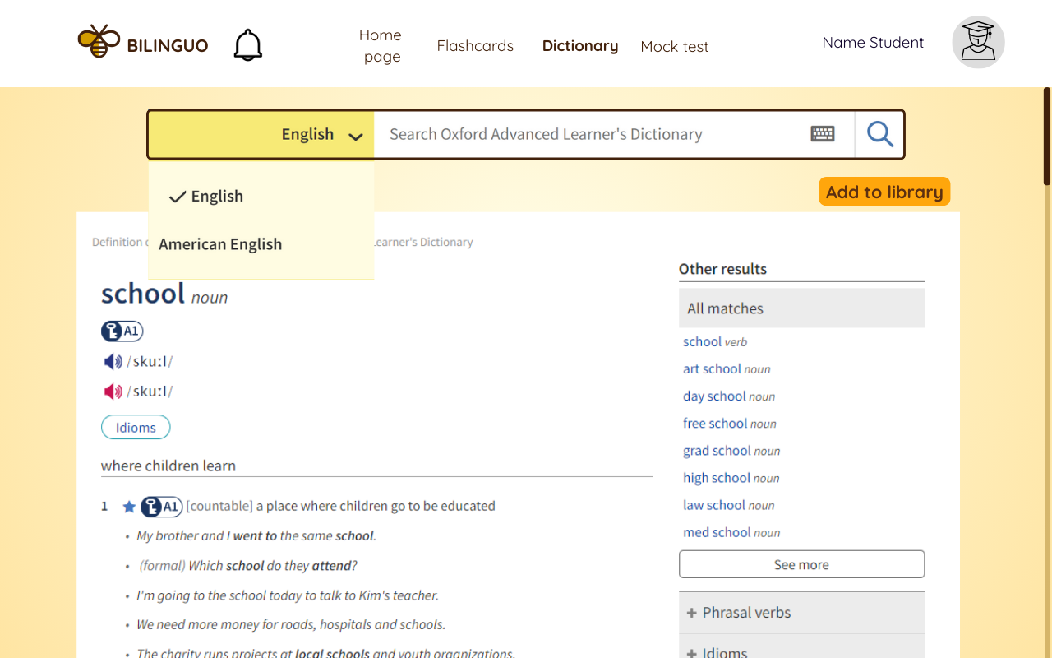

* **For the learner role, users can utilize the "Add to library" feature to add vocabulary to their flashcard library.**

## 

# 4. Teacher role

## 4.1. Teacher’s Homepage

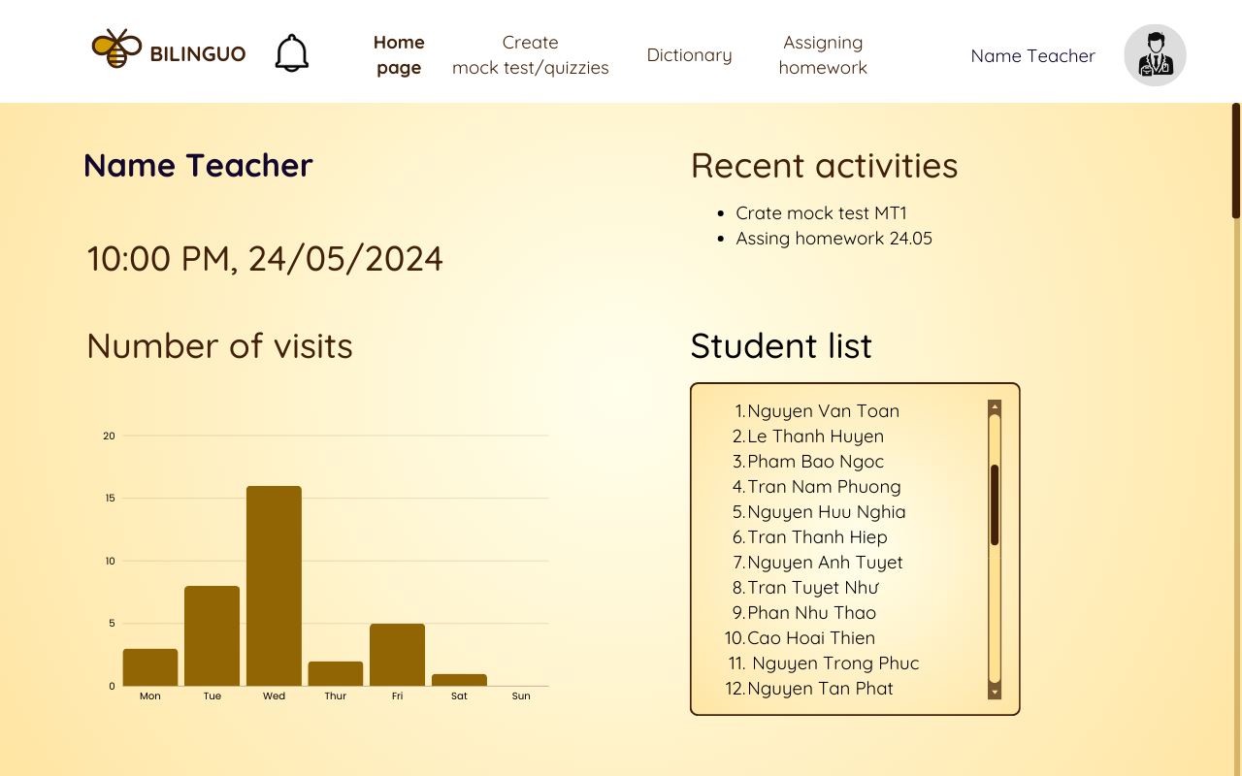

**- Purpose:** Display a dashboard for class information statistics and linked to key features.

**- User guide:** From the main screen, teachers can view essential information about the class, personal profile, new

notifications, **Create mock test/quizzies**, look up dictionary terms (**Dictionary**), and **Assigning homework**.

## 4.2. Create mock test/quizzies

## 

**- Purpose:** Create quizzes to assess learners.

**- User guide:** On the test creation screen, teachers can add questions and answers for each section. Teachers can edit the quiz using features like **Text**, **Answer box**, **Remove**, **Outline**, and **Set time**.

## 4.3. Dictionary

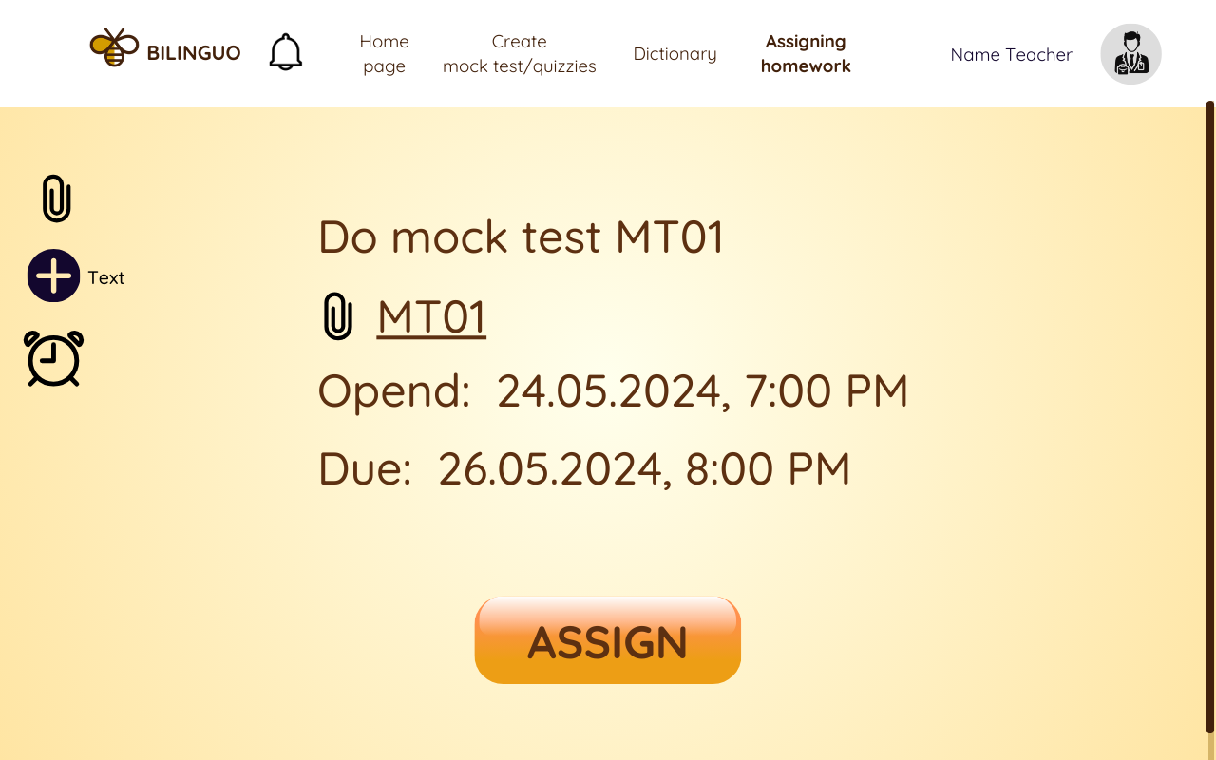

**- Purpose:** Assign homework for learners to practice.

**- User guide:** Teachers can attach homework files or create question sets. Teachers can set the deadline and click the **Assign** button to assign the homework.

# 5. Leaner role

## 5.1. Sign up

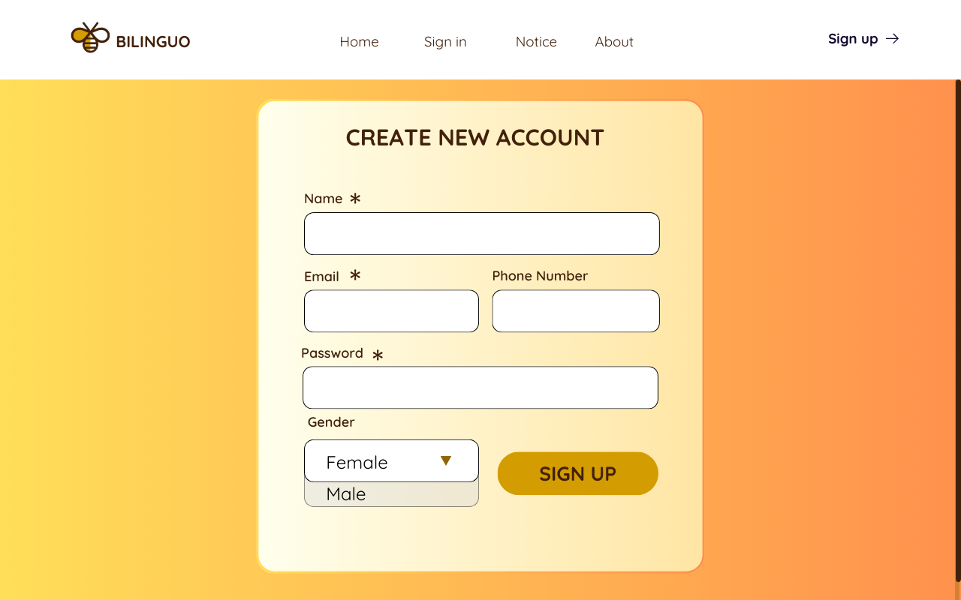

**- Purpose:** Create a new account for learners who don't have an existing one.

**- User guide:** Users input personal information such as name, email, phone number, password, gender, and then click the **Sign up** button.

## 5.2. Leaner’s homepage

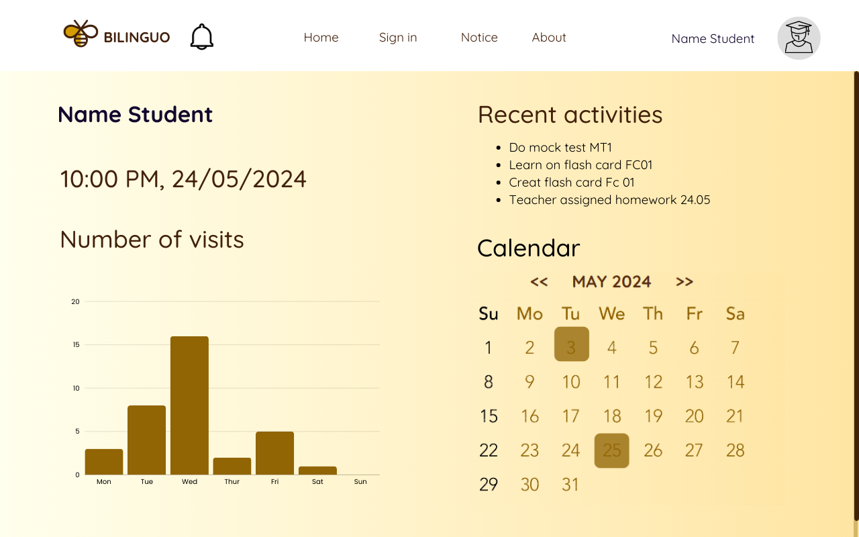

**- Purpose:** Enable learners to track class activities and deadlines.

**- Usage guide:** Learners can view a **Calendar** with marked deadlines, access statistics on user activity, and monitor ongoing activities.

## 5.3. Flashcards

### **5.3.1. Flashcards library**

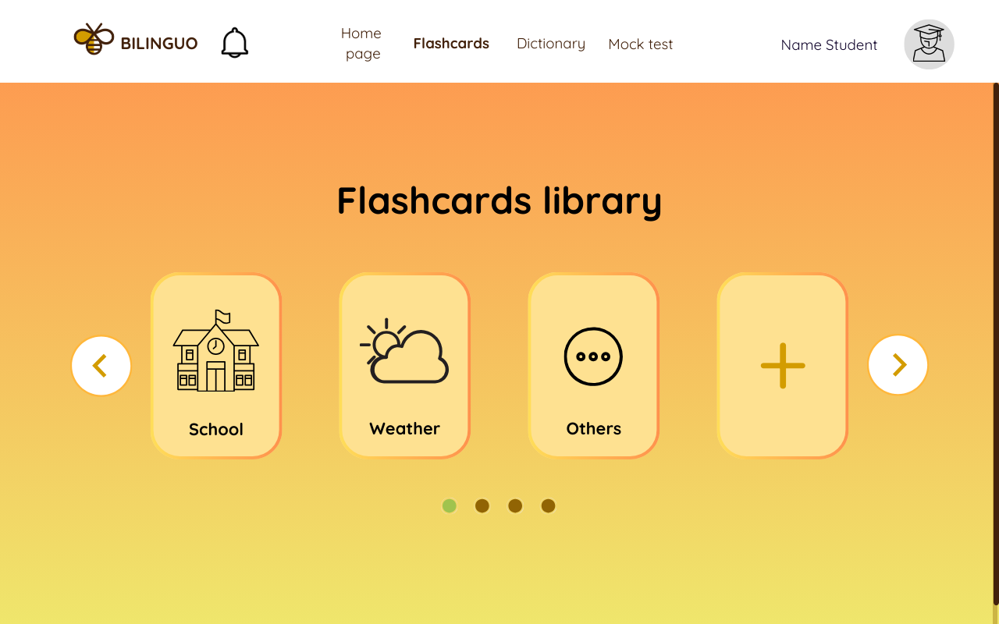

**- Purpose:** Allow learners to view their saved flashcard collections or create new ones.

**- Usage guide:** In the flashcards feature screen, learners can press on each album to select, view, edit, or create new flashcard albums.

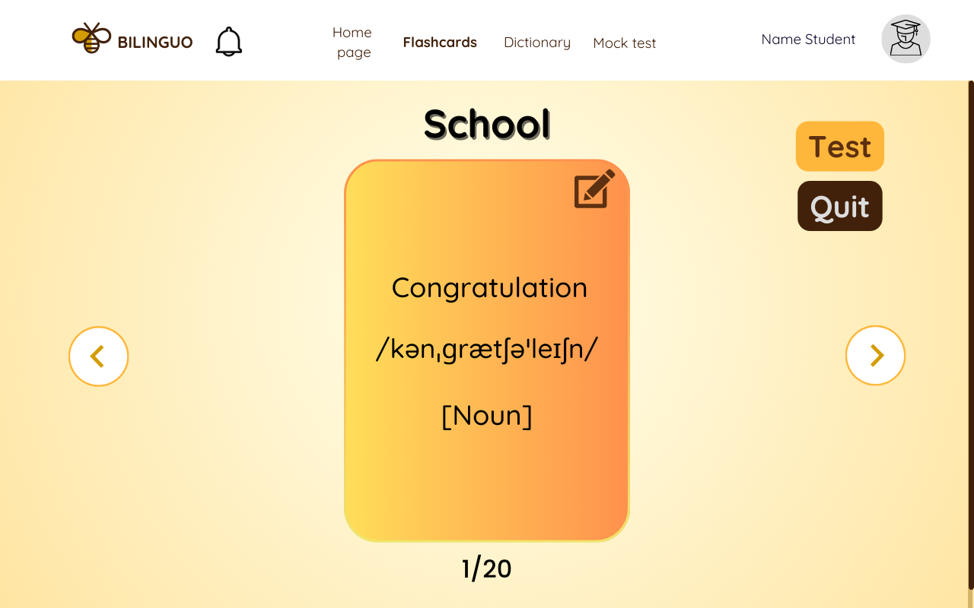

* After clicking on the 'School' flashcard album, users will be directed to the interface where they can view, edit, or create new flashcards within that specific album.

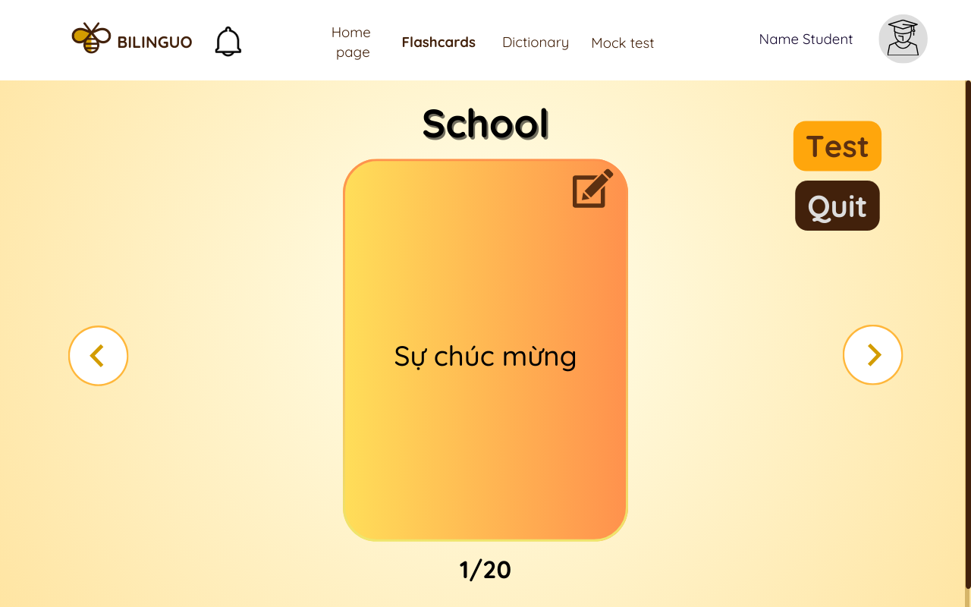

* By tapping on each flashcard, users can flip them over to view the meaning of the word.
* Users can select the Test feature to assess their vocabulary retention.

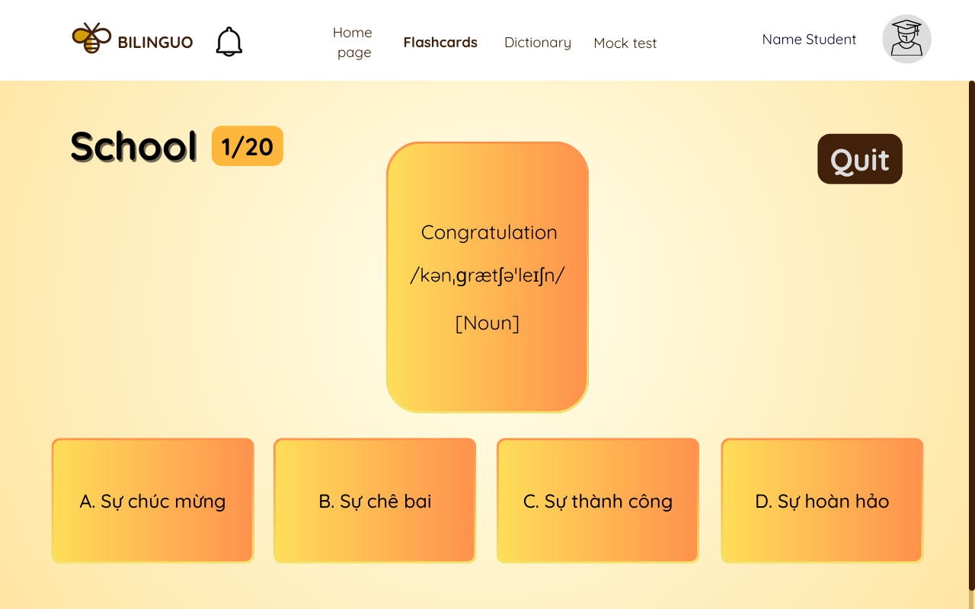

* After pressing the **Test** button, users will be directed to the test interface.

### **5.3.2. Create Flashcards**



**- Purpose:** Create a new set of flashcards to learn additional vocabulary.

**- Usage guide:** On the flashcards library screen, users can click on the **“+” icon** to create a new set of flashcards.

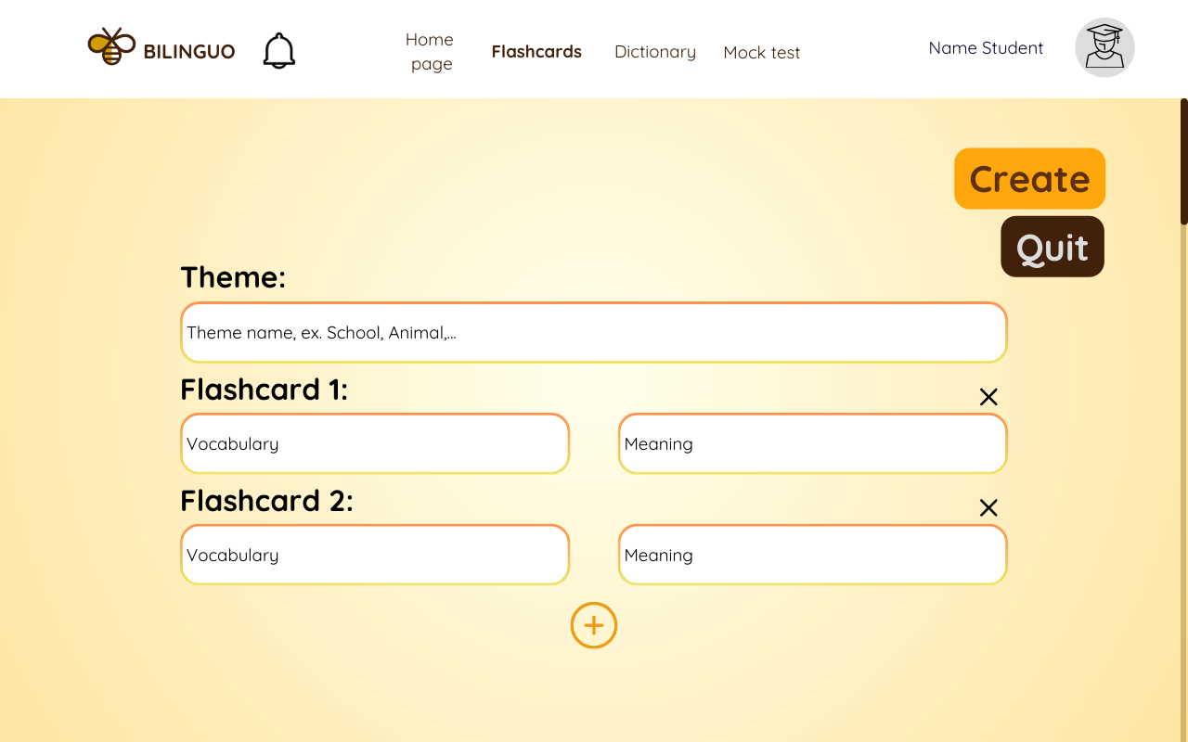

* After selecting to add a flashcard, users need to input the topic name and flashcard information. Users can add flashcards by tapping on the **“+”** sign below the screen or delete flashcards by pressing the **“x”**  icon on the right side of the flashcard.
* When editing is complete, users press the **Create** button to add the flashcard set to the library.
* Users can press the **Quit** button to cancel the flashcard creation process.

## 5.4. Mock test

**- Purpose:** Assess learners' proficiency.

**- Usage guide:**

+ Users can prioritize sections to work on first in the outline section.

+ The test will be in multiple-choice format, with answers entered into the text box.

+ Users can view the remaining time in the middle of the screen.

+ After completing the test, users press the **Submit** button to submit their answers.

+ Users can exit the test by pressing the **Quit** button.

# 6. Admin role

## 6.1. Admin’s homepage

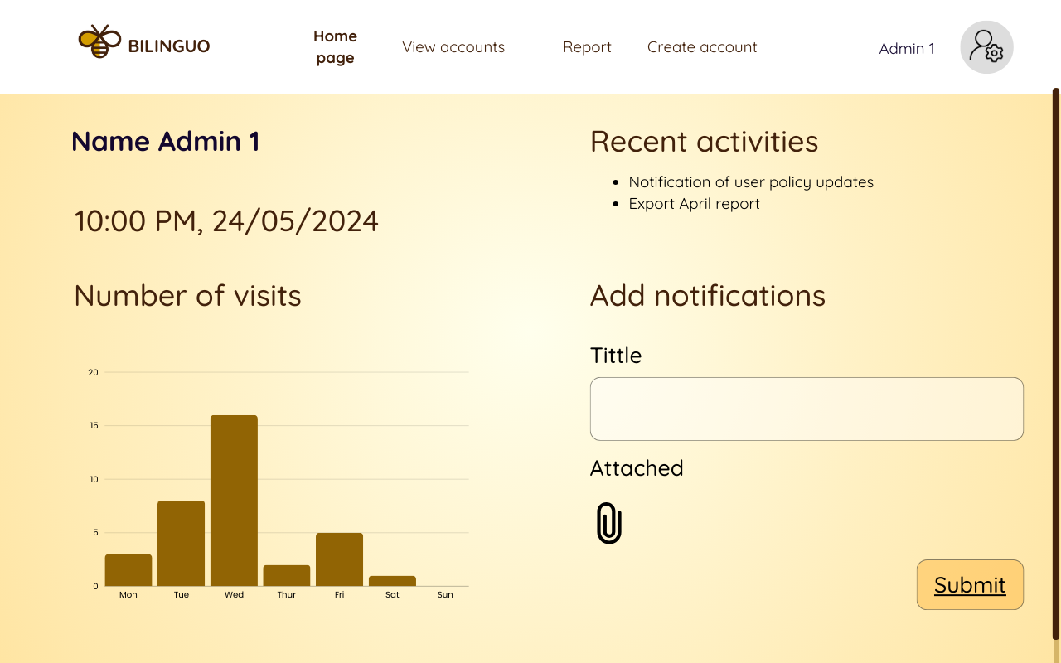

**- Purpose:** Aid the admin in tracking statistical information and delivering news updates to users.

**- Usage guide:** The admin can click on the **Add notifications** area to create notifications for users and then click **Submit** to send them.

## 6.2. View accounts

## 

**- Purpose:** Enable the admin to view user information by role and account details.

**- Usage guide:** There are three sections available: **"Student list", "Teacher list"** and **"Recently created accounts"** where the admin can view user information categorized accordingly.

## 6.3. Report

## 

**- Purpose:** Export user account statistics.

**- Usage guide:** The admin views the statistics information and clicks on **Export** to generate a file containing the statistics data.

## 6.4. Authorize account

## 

**- Purpose:** Admin assigns special accounts to teachers.

**- Usage guide:** The admin enters the personal information of the teacher and clicks **Sign up** to create the teacher's account.